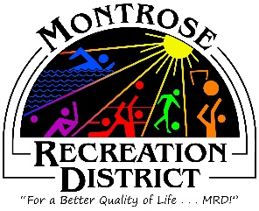

Regular Meeting of the
Montrose Recreation District (MRD) Growth Committee
Thursday, June 17, at 2pm
Montrose Community Recreation Center
16350 Woodgate Road
Montrose CO 81401

Minutes

- Status/Update
  - Progress report of outstanding items; given throughout report
  - Monthly formal report to elected officials. Mari will attend the next City Council Meeting to give a report on the Master Plan.
  - Inventory Analysis; Logan Simpson (who works with PROS Consulting) came to town and looked at District and City parks and facilities. They created a spreadsheet with the inventory. Each park and facility was scored based on; below expectations, meets expectations, above expectations. It was suggested that PROS work with the City on GSI mapping on parks.
- Public Engagement
  - Outcomes from virtual Public Meetings; there were several comments in June from Pickle ball users that the tennis courts used for the pickle ball tournaments are in very poor shape.
  - Statistically Valid and online survey; By the end of July we should have statistically reliable survey responses available.
  - Intercept Survey – was offered at FUNC Fest June 12. There were 32 responses.
    - It was suggested that MRD put calendar together for events that we can offer survey at. Debby will do and send out to Growth Committee and staff to work these events. It will be sent out to programers to populate. Include open swim at Field House, Summer Concert Series, Youth Appreciation Day, HAP, Farmer’s Market. Library events, Fair and Rodeo, Kiosk at CRC for Park and Rec Month. Debby will make more cards with QR codes as well as the Survey Monkey site, MakeMyMontrose site as well as Happifeet app. so people can fill it out electronically. It was suggested that paper surveys be offered as well.
    - It was decided that the questions will remain the same.
  - Website still open/review comments
  - June 24 Mari will be speaking at The Forum. She will also be interviewed on Our Town Matters, Montrose Live in July. She will talk about the Master Planning Process.
  - HAPPiFEET – app. Is very close to launch, should happen by July.
  - A CAC (Citizen Advisory Committee) was discussed again. It was suggested that the Montrose Rec Foundation take on the task of forming a CAC. Debby will work with Amy on getting Stakeholders to attend an event to get people interested in participating.

Next meeting
Thursday, July 15, 2021 at 2pm
Montrose Community Recreation Center
16350 Woodgate Road
Montrose, CO 81401

