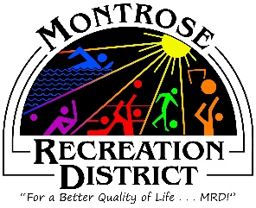

Notice of A Special Meeting of the
Montrose Recreation District (MRD) Board of Directors
Finance & Growth Committees Workshop
Tuesday, October 3, at 8:00am
Montrose Community Recreation Center
16350 Woodgate Road
Montrose CO 81401

- Call to Order, Roll Call (Files, Otto, Wiesner, Howe)

- Purposes of the meeting, joint goals

- Capital Improvement Budget & Master Plan Materials

- Adjourn

Next BOD Regular Meeting
October 27 at 11:30am
CRC 16350 Woodgate Road
Montrose CO 81401

